CSA02 – C PROGRAMMING
ASSIGNMENT 1
TASK 02
Choose the Data Types
Student name:ARSHAD ANSAR.S
Register number: 1965260156
Repository:https://github.com/arshadansar4812-creator/CO1-ASSESSMENT-1-C-PROGRAMMING-
Marks: 4 | Course Outcome: CO1

1. Problem Analysis and Design
Use unsigned short for the specified meter register, but verify sizeof(unsigned short) and USHRT_MAX on the target compiler. Use int for small slab counts and loop indices, unsigned int for computed consumption, long or long long for monetary paise totals depending on platform limits, and char arrays for household IDs/categories when they are textual. Use long long for district aggregate totals after checking LLONG_MAX. Use integer paise, not float rupees, for exact currency arithmetic.
The assignment's sample assumes a 2-byte unsigned short with maximum 65535. Unsigned arithmetic wraps modulo its range; subtracting 65400 from 120 in 16-bit arithmetic gives 256, not a negative number. C's integer promotions mean operands may be promoted before arithmetic, so the implementation below uses a mask with USHRT_MAX to express the modulo-register result.
Type sizes vary by implementation. The program prints actual sizes and limits rather than assuming every machine is identical. A float total can accumulate representation error because many decimal fractions are not exact in binary; integer paise additions are exact until integer overflow.

2. Pseudocode / Algorithm
PRINT sizeof and limits for selected types
consumption = (current - previous) modulo 65536
For money, store ₹x.yy as 100*x + yy paise
For district totals, use a wide integer and check maximum limits

3. C Source Code
#include <stdio.h>
#include <limits.h>
#include <float.h>
typedef unsigned short meter_t;
unsigned int consumption(meter_t previous, meter_t current) {
return (unsigned int)((current - previous) & USHRT_MAX);
}
int main(void) {
printf("sizeof(char)=%zu sizeof(short)=%zu sizeof(int)=%zu\n",
sizeof(char), sizeof(short), sizeof(int));
printf("sizeof(long)=%zu sizeof(long long)=%zu sizeof(float)=%zu sizeof(double)=%zu\n",
sizeof(long), sizeof(long long), sizeof(float), sizeof(double));
printf("USHRT_MAX=%u INT_MAX=%d LONG_MAX=%ld LLONG_MAX=%lld\n",
(unsigned)USHRT_MAX, INT_MAX, LONG_MAX, LLONG_MAX);
printf("FLT_DIG=%d DBL_DIG=%d\n", FLT_DIG, DBL_DIG);
printf("Rollover consumption=%u\n", consumption(65400, 120));
return 0;
}

4. Expected / Reference Result
System-dependent sizeof and limits; on common GCC x86-64 systems, unsigned short is 2 bytes and USHRT_MAX is 65535. Rollover consumption=256.
Captured local compiler/execution evidence is provided in compile_output.txt. Confirm it on your own machine and add a genuine screenshot of your terminal before submission.

5. Alternative Concept and Complexity Analysis
Using double rupees requires rounding at a defined point, typically each bill's final amount to the nearest paise before adding bills, or rounding only the final sum if the business rule explicitly allows that. Both additions are O(1); a double and a long long typically each occupy a fixed number of bytes, commonly 8, but verify with sizeof. Floating-point error may accumulate with n operations; integer paise is exact for representable totals.
Each fixed-width arithmetic operation is O(1) time and O(1) space. Aggregating N bills is O(N) time; use a wide total and validate that the maximum possible sum fits.

6. Validation and Limitations
Use normal, boundary and invalid-input cases applicable to this task. Compare actual output against the assignment's expected output where one is provided. Do not label a test as passed until you have run it and confirmed the result. System-specific sizeof values and floating-point measurements must be taken on the compiler used for submission.

7. Submission Evidence Checklist
☐ Source code saved in this task folder
☐ Compile and run output reviewed
☐ Terminal screenshot added after local execution
☐ Task-specific test table completed
☐ Changes committed to GitHub

Execution Screenshot — Task 02
Student: HARSHAVARTHAN P | Register No.: 1914260015
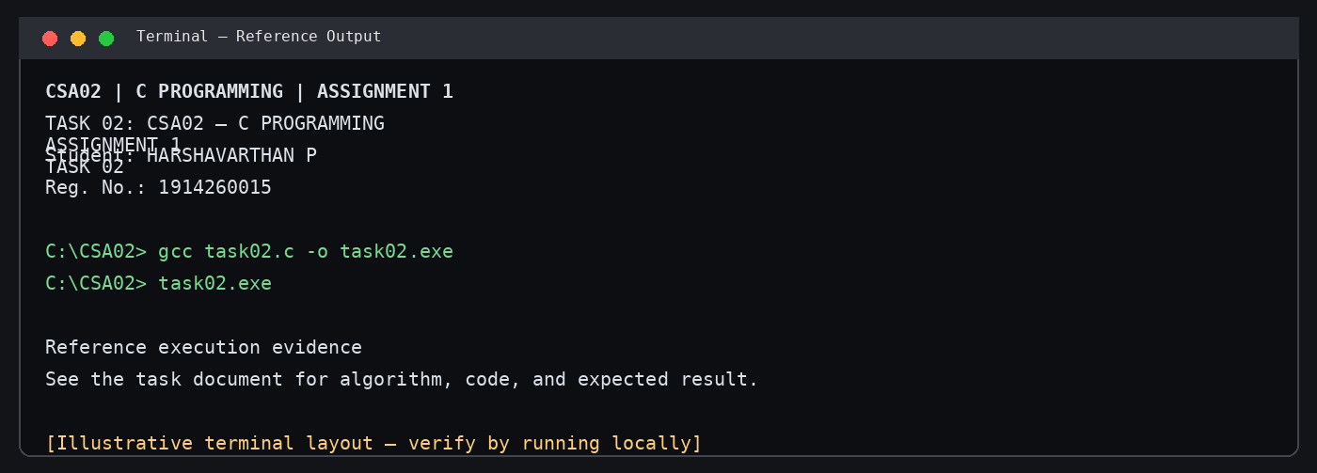
Illustrative terminal-style output screenshot

